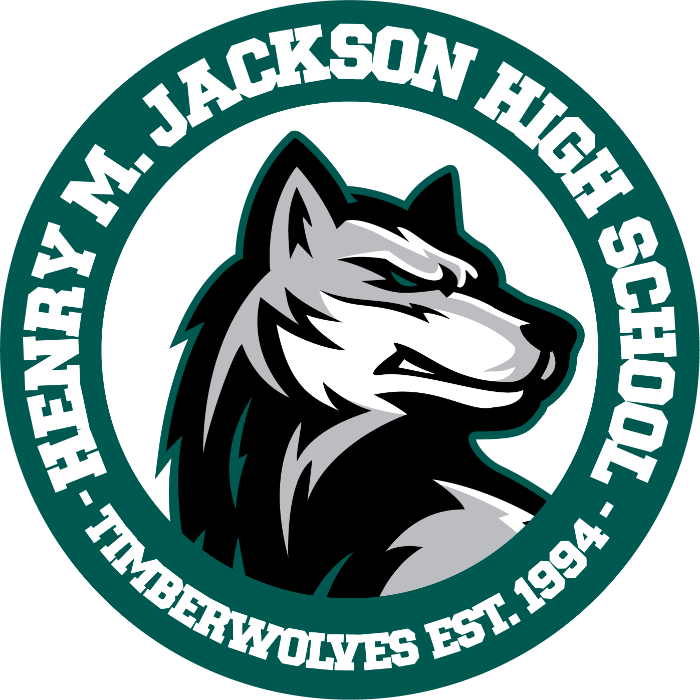 |  | Henry M. Jackson High School  1508 136th Street SE  Mill Creek, WA 98012  Phone (425) 385-7000 Fax (425) 385-7044
Sechin Tower Ariana Burton-Rodgriguez Erik Heinz Janel Thompson
Principal Assistant Principal Assistant Principal Assistant Principal

